Pancakes | 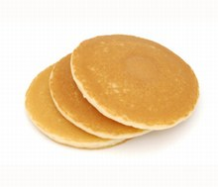
MATERIALS NEEDED
Ingredients | Kitchen Supplies
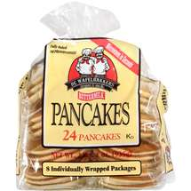  frozen pancakes | 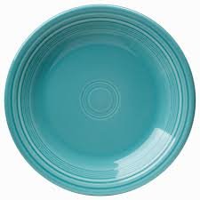  plate
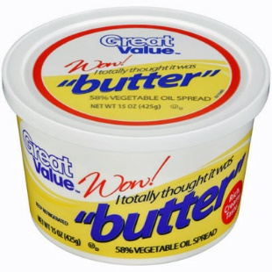  butter  syrup | 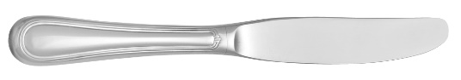  knife
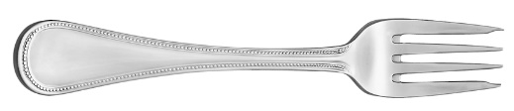

fork
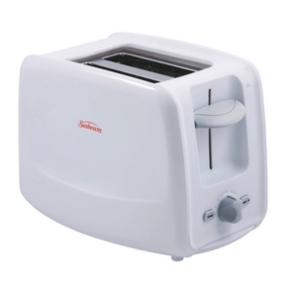
toaster

Pancakes
DIRECTIONS
1 | Take 2 pancakes from the package and put them in the microwave. | 5 | Use a knife to spread butter on both pancakes.
2 | Set the microwave to 1 minute and press the lever down. | 6 | Pour syrup on both pancakes.
3 | Wait for the timer to beep. | 7 | Use your knife and fork to cut your pancakes into pieces.
4 | Remove pancakes from the microwave. | 8 | Eat.

