Cinnamon Toast | 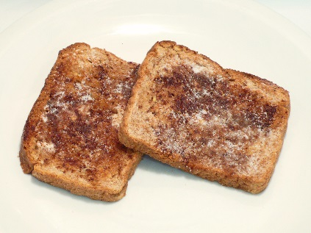
MATERIALS NEEDED
Ingredients | Kitchen Supplies
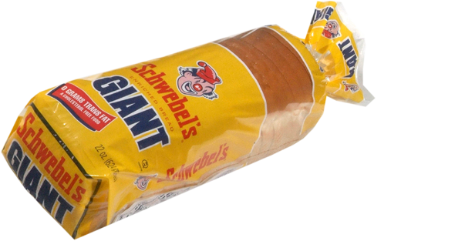  bread | plate
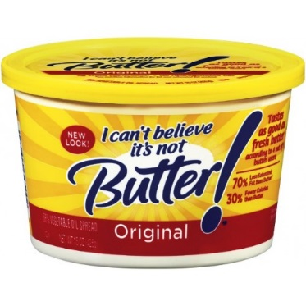  butter | 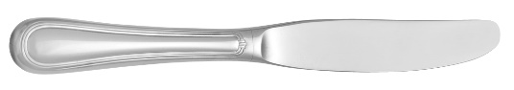  knife
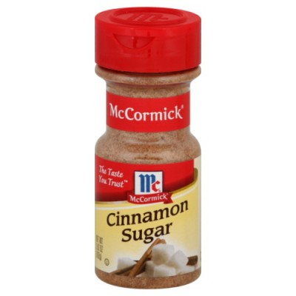  cinnamon sugar | 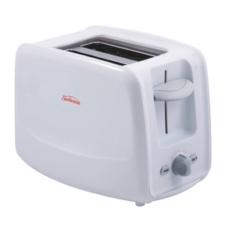  toaster

Cinnamon Toast |  | 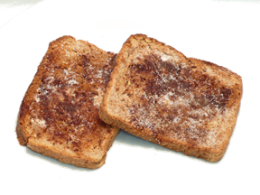
DIRECTIONS
1 | Remove two pieces of bread from the bag and put them in the toaster. | 5 | Use a knife to spread butter on the other piece of the bread.
2 | Set the toaster to 2 and press the lever down. | 6 | Sprinkle cinnamon sugar on the toast.
3 | After the bread pops up, take the pieces out of the toaster and place them on your plate. | 7 | Enjoy!
4 | Use a knife to spread butter on one piece of the bread.

