Fluffernutter | 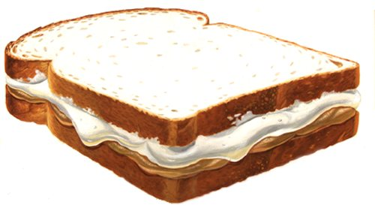
MATERIALS NEEDED
Ingredients | Kitchen Supplies
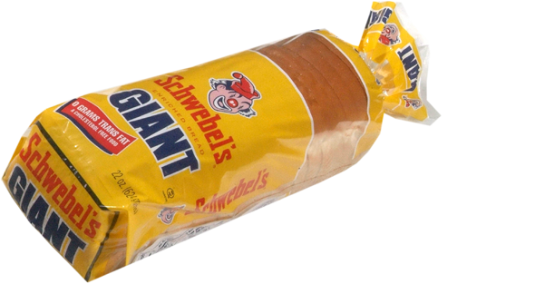  bread | plate
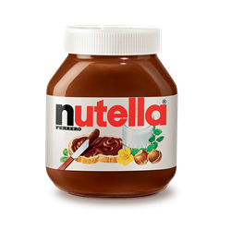  Deli Meat | 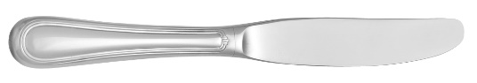  knife
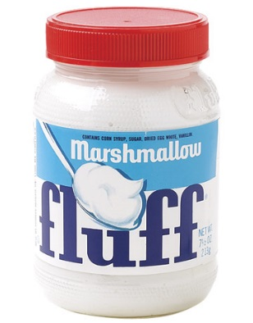  Condiments | 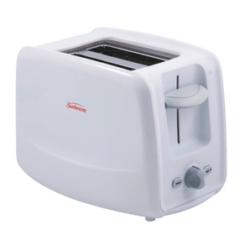  toaster

Fluffernutter
DIRECTIONS
1 | Remove two pieces of bread from the bag and put them in the toaster. | 5 | Spread marshmallow fluff on the other side of your bread and spread it with a knife.
2 | Set the toaster to ??? and press the lever down. | 6 | Stack one piece of bread on top of the other.
3 | After the bread pops up, take the pieces out of the toaster and place them on your plate. | 7 | Eat.
4 | Spread Nutella on one side of your bread and spread it with a knife. | 8

